Data Representation

Lab 05.3: AJAX calls to REST

Lecturer: Andrew Beatty

In this lab we want to make the AJAX calls that will call the RESTful API

* The server serves out a RESTfull api that performs CRUD operations on cars

|  |  |  |  |  |
| --- | --- | --- | --- | --- |
| Action | Method | URL | Sample params | Sample return |
| Get all | GET | /cars | none | {  cars:[  {…},{…},{…}  ]  } |
| Find by id | GET | /cars/*reg* | none | {car:  {  "reg":"12 D 1234",  "make":"Fiat",  "model":"Punto",  "price":3000  }  } |
| Create | POST | /cars | {  "reg":"12 D 1234",  "make":"Fiat",  "model":"Punto",  "price":3000  } | {  "reg":"12 D 1234",  "make":"Fiat",  "model":"Punto",  "price":3000  } |
| Update | PUT | /cars/*reg* | {  "price":3000  } | {  "reg":"12 D 1234",  "make":"Fiat",  "model":"Punto",  "price":3000  } |
| delete | DELETE | /cars/*reg* | none | {  "done":true  } |

1. Test that we can call the server from the web page, by creating a webpage called testgetall.html.
2. open browser and open <http://127.0.0.1:5000/testgetall.html>

<html>

    <head>

        <script src="https://ajax.googleapis.com/ajax/libs/jquery/3.4.1/jquery.min.js"></script>

        <title>

            test get all

        </title>

    </head>

    <body>

        <button onclick="getAll()">getAll</button>

        <div id="output"></div>

        <table id="carsTable">

            <tr>

                <th>reg</th><th>make</th><th>model</th><th>price</th><th></th><th></th>

            </tr>

        </table>

    </body>

    <script>

        function getAll(){

            $.ajax({

                "url": "http://127.0.0.1:5000/cars",

                "method":"GET",

                "data":"",

                "dataType": "JSON",

                "success":function(result){

                    console.log(result);

                },

                "error":function(xhr,status,error){

                    console.log("error: "+status+" msg:"+error);

                }

            });

        }

    </script>

</html>

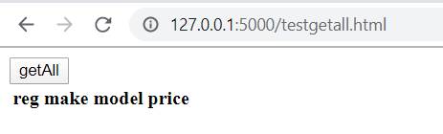

1. If you get this error,

Access to XMLHttpRequest at 'http://127.0.0.1:5000/cars' from origin 'null' has been blocked by CORS policy: No 'Access-Control-Allow-Origin' header is present on the requested resource.

it is because you opened the html file directly and did not through the server. Id the url looks like. <file:///C:/morespace/Dropbox/gmit/dataRepresentation/code/week05-REST/testgetall.html>

1. Modify this url to all each of the cars to the table (you have the code from week to that adds a car to a table, you just need to call it from success function for each car.

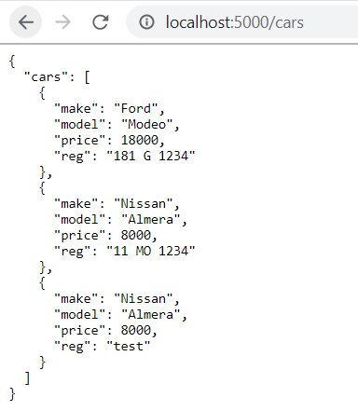

# create

1. Make a web page that tests the create

function createCar(){

            var car = {"reg":"12 D 1234","make":"Fiat","model":"Punto","price":3000}

            console.log(JSON.stringify(car));

            $.ajax({

                "url": "http://127.0.0.1:5000/cars",

                "method":"POST",

                "data":JSON.stringify(car),

                "dataType": "JSON",

                contentType: "application/json; charset=utf-8",

                "success":function(result){

                    console.log(result);

                    document.getElementById("output").innerText = JSON.stringify(result);

                },

                "error":function(xhr,status,error){

                    console.log("error: "+status+" msg:"+error);

                }

            });

        }

python a_simpleserver.py

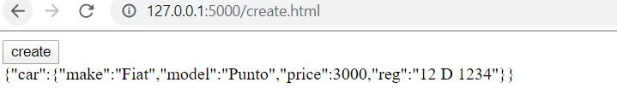

## update

1. Test the update

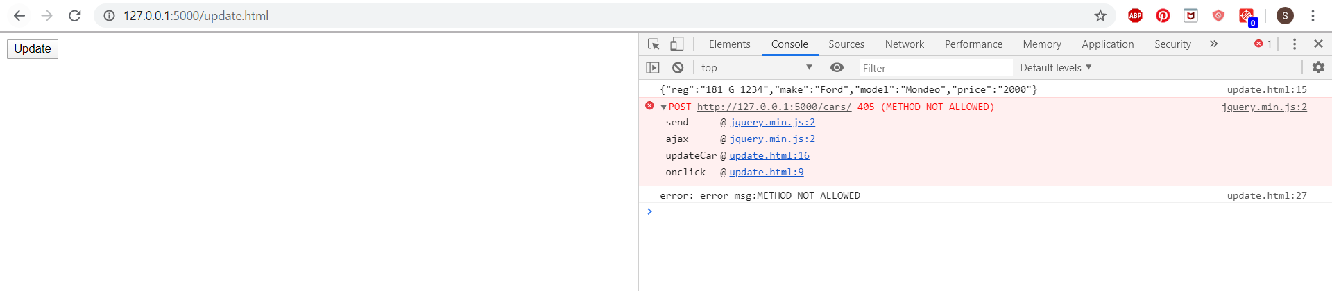

 function updateCar(){

            var car = {"reg":"181 G 1234","make":"Ford","model":"Modeo","price":"00"}

            console.log(JSON.stringify(car));

            $.ajax({

                "url": "http://127.0.0.1:5000/cars/"+encodeURI(car.reg),

                "method":"PUT",

                "data":JSON.stringify(car),

                "dataType": "JSON",

                contentType: "application/json; charset=utf-8",

                "success":function(result){

                    console.log(result);

                    document.getElementById("output").innerText = JSON.stringify(result);

                },

                "error":function(xhr,status,error){

                    console.log("error: "+status+" msg:"+error);

                }

            });

        }

Methods post and put not allowed

## delete

1. test delete

function deleteCar(){

            var car = {"reg":"12 D 1234"}

            console.log(JSON.stringify(car));

            $.ajax({

                "url": "http://127.0.0.1:5000/cars/"+encodeURI(car.reg),

                "method":"DELETE",

                "data":"",

                "dataType": "JSON",

                contentType: "application/json; charset=utf-8",

                "success":function(result){

                    console.log(result);

                    document.getElementById("output").innerText = JSON.stringify(result);

                },

                "error":function(xhr,status,error){

                    console.log("error: "+status+" msg:"+error);

                }

            });

        }